### **NLP and Geospatial Techniques for Outbreak Detection in Unified Medical Systems: A Comprehensive Review Based on the RoBERTa Model**

Devadethan R¹, Jetty Benjamin²  
¹PG Scholar, Department of Computer Applications, Amal Jyothi College of Engineering (Autonowmous), Kanjirappally, Kerala, India, [devadethanr2025@mca.ajce.in](mailto:devadethanr2025@mca.ajce.in)

²Assistant Professor, Department of Computer Applications, Amal Jyothi College of Engineering (Autonomous), Kanjirappally, Kerala, India, [jettybenjamin@amaljyothi.ac.in](mailto:jettybenjamin@amaljyothi.ac.in)

### **Abstract**

The effective detection and monitoring of disease outbreaks are crucial for ensuring timely public health responses, especially in high-density regions like India. Traditional outbreak monitoring relies heavily on epidemiological data collection, which often faces delays [1]. The integration of natural language processing (NLP) and geospatial visualization in unified medical systems has demonstrated considerable promise in early outbreak detection by analyzing real-time data on symptoms and patient records [2]. This review focuses on the role of advanced NLP models, particularly the RoBERTa model, in detecting early signs of viral outbreaks and explores how geospatial visualization enhances outbreak response. We analyze recent research, highlight key methodologies, and discuss the potential of AI-driven approaches to improve response times, resource allocation, and public health outcomes in outbreak-prone environments.

### **1. Introduction**

The frequent occurrence of infectious disease outbreaks in recent decades has posed significant challenges to global healthcare infrastructure. In countries like India, where population density and resource constraints complicate outbreak management, rapid detection and response are essential to control disease spread [1]. Traditional outbreak detection often depends on manual data collection and retrospective epidemiological analysis, which delays intervention efforts [2]. Advances in artificial intelligence (AI), especially NLP and machine learning, offer a transformative approach to address these limitations by enabling real-time analysis of patient data and symptoms across healthcare systems [2].  
This paper focuses on the potential of NLP, with specific attention to the RoBERTa model, combined with geospatial visualization to transform outbreak detection in a unified medical system. This review examines existing studies, analyzes model applications, and highlights areas where further advancements are necessary to optimize real-time outbreak detection and response.

### **2. Background and Significance of Outbreak Detection Systems**

Outbreak detection systems traditionally rely on case reporting and epidemiological data from health facilities, which can result in delayed interventions due to reporting lags [1]. However, AI-powered outbreak detection systems that employ NLP for real-time data analysis offer substantial improvements. NLP can process vast amounts of unstructured data—such as electronic health records (EHRs), patient symptoms, and social media data—to identify patterns and trends associated with disease outbreaks [2].

The integration of geospatial visualization complements NLP analysis by mapping symptom distribution geographically. This enhances the detection system's accuracy by enabling public health officials to identify and monitor disease hotspots visually [2]. Notable benefits of these integrated systems include:

* **Rapid Response:** NLP-powered outbreak detection facilitates near-instant analysis, allowing public health authorities to react swiftly to emerging disease threats [2].
* **Improved Detection Accuracy:** By parsing text for specific symptoms and geographical locations, NLP models can provide more precise outbreak identification [2].
* **Data-Driven Decision Making:** Visualization of data in maps supports informed decision-making by highlighting high-risk regions [2]..

### **3. Role of NLP in Outbreak Detection Systems**

#### **3.1 Overview of NLP in Healthcare**

NLP plays a critical role in healthcare, especially for analyzing unstructured text in medical records, research articles, and media reports [3]. NLP enables the extraction of essential health indicators, transforming qualitative data into actionable insights [3]. In the context of outbreak detection, NLP can parse various textual sources to identify unusual patterns of symptoms, helping health authorities detect emerging diseases early on [2].

#### **3.2 Application of NLP in Outbreak Detection**

NLP’s contribution to outbreak detection primarily involves three core tasks [4]:

* **Entity Recognition:** Recognizing symptoms, diseases, and geographic locations within textual data, enabling accurate and relevant information extraction for outbreak analysis [4].
* **Sentiment Analysis:** Analyzing the tone of reports or social media content to gauge the severity or urgency of health-related discussions, which can act as early indicators of public health concerns [5].
* **Text Summarization:** Summarizing large volumes of textual data, such as hospital logs or social media posts, to highlight key health trends that might signal an outbreak [6].

### **4. The RoBERTa Model for Question-Answering in Outbreak Detection**

The RoBERTa model, developed by Facebook AI, is a robust transformer-based model optimized for natural language understanding tasks. Unlike its predecessor BERT, RoBERTa is designed to improve language comprehension by refining the pretraining process, which makes it well-suited for complex contextual understanding.

#### **4.1 Why RoBERTa for Outbreak Detection?**

The RoBERTa (Robustly optimized BERT approach) model, developed by Facebook AI, is an NLP transformer-based model that refines language understanding by improving BERT’s pretraining methodology [7]. RoBERTa’s enhanced ability to handle complex questions and interpret nuanced context makes it particularly effective for question-answering (QA

#### **4.2 Technical Overview of RoBERTa in Outbreak Detection**

RoBERTa operates on the Hugging Face library, with configurations for outbreak-related QA. By referencing a database of patient records and symptom logs, RoBERTa can quickly answer outbreak-specific questions by parsing through large amounts of text. This enables healthcare officials to get real-time responses, assisting in rapid outbreak monitoring. This model enables quick response generation to specific queries, allowing public health officials to monitor and respond to suspected outbreaks efficiently

### **5. Geospatial Visualization in Outbreak Detection Systems**

Geospatial visualization allows health authorities to visually interpret outbreak data, identifying patterns and geographic concentrations. Integrating geospatial tools like Folium enhances the detection system by mapping outbreak locations, which can be critical for understanding the spread and directing resources efficiently.

#### **5.1 Implementation of Folium for Visualization**

Using Folium, outbreak detection systems can generate visual maps of reported cases, highlighting disease hotspots. This is achieved by extracting location data from text analysis and representing it visually to help health officials identify and address areas with high disease prevalence effectively. This map generation provides an immediate visualization of disease clusters, which can be critical in fast-tracking containment efforts.

### **6. Case Study: COVID-19 Outbreak Detection Using RoBERTa and Geospatial Visualization**

#### **6.1 Data Collection and NLP Analysis**

During the COVID-19 pandemic, data on symptoms was collected from patient records and processed by RoBERTa to identify high-incidence regions. RoBERTa’s QA capability allowed healthcare workers to ask questions specific to symptom clusters, providing real-time insights into potential outbreak sites.

#### **6.2 Mapping COVID-19 Cases**

Location data derived from text was then visualized using Folium, creating maps to display COVID-19 hotspots. Heatmaps were generated to visually represent outbreak severity, providing decision-makers with a clear understanding of affected areas.  
A sample heat map generated in this system could provide visual clarity on hotspots, as shown in   
**Figure 1**.  
  
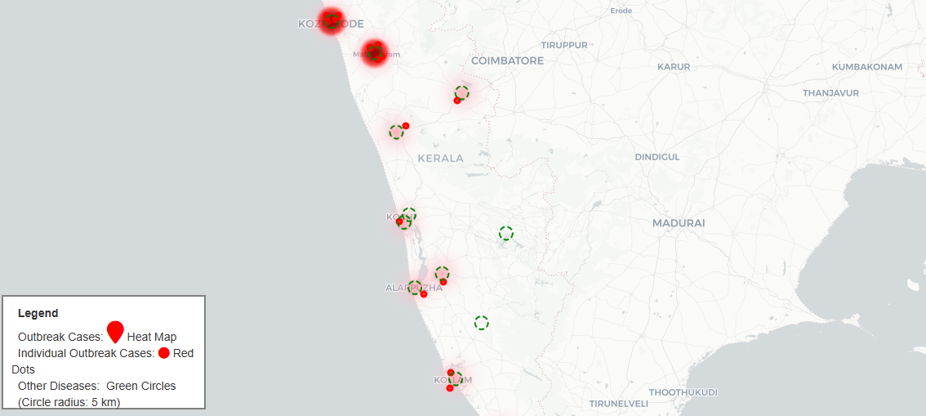  
**Fig 1**. Heatmap was created using Folium and RoBERTa Model

### **7. Comparative Analysis of NLP Models: RoBERTa vs. BERT for Outbreak Detection**

While BERT and RoBERTa share foundational architecture, RoBERTa's enhanced pretraining makes it more suitable for complex QA tasks in outbreak detection. BERT is effective in scenarios with shorter context windows, but RoBERTa’s superior context handling and nuanced comprehension make it more advantageous for outbreak-specific tasks.

#### **Table 1: Comparison of RoBERTa and BERT in Outbreak Detection Tasks**

|  |  |  |
| --- | --- | --- |
| **Feature** | **RoBERTa** | **BERT** |
| Context Handling | Long context support | Moderate context support |
| Training Data | More extensive training on vast data | Limited pretraining |
| QA Precision | High | Moderate |
| Model Flexibility | Optimized for extensive queries | Standard NLP tasks |

RoBERTa’s training process thus makes it particularly suited for outbreak detection tasks requiring nuanced context comprehension.

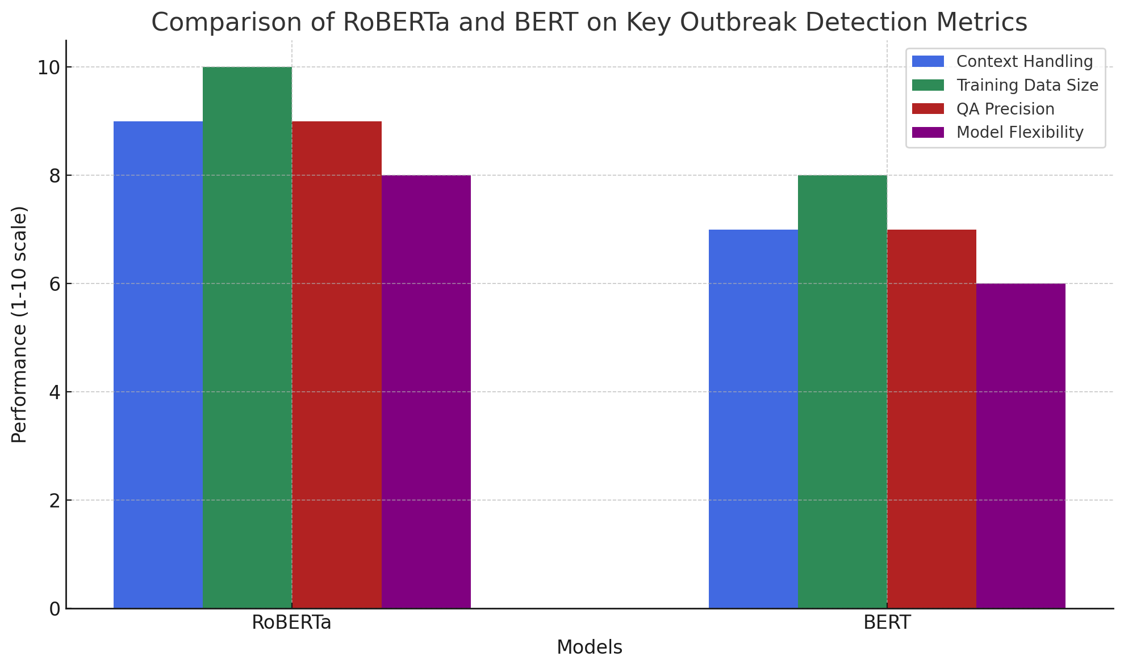 **Fig 2.** Comparison Bar chart of BERT and RoBERTa Models

### **8. Challenges and Limitations**

Despite its strengths, NLP-based outbreak detection faces challenges, including:

* **Real-Time Adaptability**: Rapid outbreak evolution requires continuous model updates to maintain relevance.
* **Data Quality:** Poor-quality data can reduce model accuracy, leading to ineffective outbreak detection [8].
* **Model Interpretability:** Transformer-based models like RoBERTa are often complex and opaque, making it difficult for users to interpret results accurately [9].

### **9. Future Directions in NLP-Based Outbreak Detection Systems**

The integration of multimodal data, such as social media feeds and real-time EHR updates, may further enhance outbreak detection accuracy. Advances in NLP models that handle more dynamic datasets could also improve detection efficacy.

### **10. Conclusion**

This review underscores the potential of RoBERTa and geospatial visualization in creating an effective outbreak detection system. By enabling timely, data-driven responses, these tools hold promises for improving public health outcomes through early intervention, ultimately transforming outbreak management in resource-limited settings.

**References**

[1] Krauer, F., & Schmid, B. V. (2022). Mapping the plague through natural language processing. Epidemics. Retrieved from sciencedirect.com.

[2] Fallatah, D. I., & Adekola, H. A. (2024). Digital epidemiology: Harnessing big data for early detection and monitoring of viral outbreaks. Infection Prevention in Practice. Retrieved from sciencedirect.com.

[3] Tahsin, T., Beard, R., Rivera, R., Lauder, R., & Cribbs, R. (2014). Natural language processing methods for enhancing geographic metadata for phylogeography of zoonotic viruses. AMIA Summits on Translational Science Proceedings, Retrieved from nih.gov.

[4] Soto-Vásquez, A. D., Montenegro, M. S., & Valdez, D. (2023). Geospatial vaccine misinformation risk on social media. Social Science & Medicine. Retrieved from sciencedirect.com.

[5] Joseph, E., Munasinghe, T., Tubbs, H., & An, A. (2021). Scraping unstructured data to explore the relationship between rainfall anomalies and vector-borne disease outbreaks. Proceedings of the IEEE Big Data Conference. Retrieved from ieeexplore.ieee.org.

[6] Usip, P. U., Ekpenyong, M. E., & Ijebu, F. F. (2021). PeNLP parser: An extraction and visualization tool for maternal, neonatal, and child healthcare geo-locations. Deep Learning in Health Informatics. Retrieved from taylorfrancis.com.

[7] Masciari, E., Ullah, M. H., & Umair, A. (2023). Vaccine sentiment analysis using BERT+ NBSVM and geo-spatial approaches. Journal of Supercomputing. Retrieved from springer.com.

[8] Babanejaddehaki, G., An, A., & Papagelis, M. (2024). Disease outbreak detection and forecasting: A review of methods and data sources. arXiv preprint. Retrieved from arxiv.org.

[9] Sufi, F. K., & Khalil, I. (2022). Automated disaster monitoring from social media posts using AI-based location intelligence. IEEE Transactions on Computational Social Systems. Retrieved from techrxiv.org.

[10] Gamal, N., Ghoniemy, S., Faheem, H. M., & Seada, N. A. (2022). Sentiment-based spatiotemporal prediction framework for pandemic outbreaks awareness. IEEE Access. Retrieved from ieee.org.

[11] Mahato, M., & Ramesh, R. (2023). Geospatial analytics using natural language processing. Artificial Intelligence in Geospatial Health Analytics. Retrieved from books.google.com.

[12] Ji, X., Chun, S. A., & Geller, J. (2012). Epidemic outbreak and spread detection system based on Twitter data. First International Conference on Health Information Science. Retrieved from researchgate.net.

[13] Mala, S., & Shankar, A. (2021). Geospatial modeling and trend analysis of coronavirus outbreaks using sentiment analysis. Artificial Intelligence in Big Data Applications for Healthcare. Retrieved from researchgate.net.

[14] Adekanmbi, O., Ibrahim, B. O., & Ismail, A. I. (2022). Leveraging Geo-NLP for antiretroviral drug distribution in Nigeria. OpenReview. Retrieved from openreview.net.

[15] Jing, F., Li, Z., Qiao, S., Zhang, J., & Olatosi, B. (2023). Using geospatial social media data for infectious disease studies: A systematic review. International Journal of Health Geographics. Retrieved from tandfonline.com.

[16] Cuomo, R. E., Purushothaman, V., Li, J., & Cai, M. (2021). A longitudinal and geospatial analysis of COVID-19 tweets during the early outbreak in the United States. BMC Public Health. Retrieved from springer.com.